**Competence Task for Python Django - Backend Developer**

**Step 1:**

1. Create a Django Project. *Used anaconda virtual environment 3.8* 
   1. Done - python 3.8 used ; python manage.py runserver
      * <http://127.0.0.1:8000/>
      * admin/[admin@del](mailto:admin@del" \t "_blank" \o "mailto:admin@del)

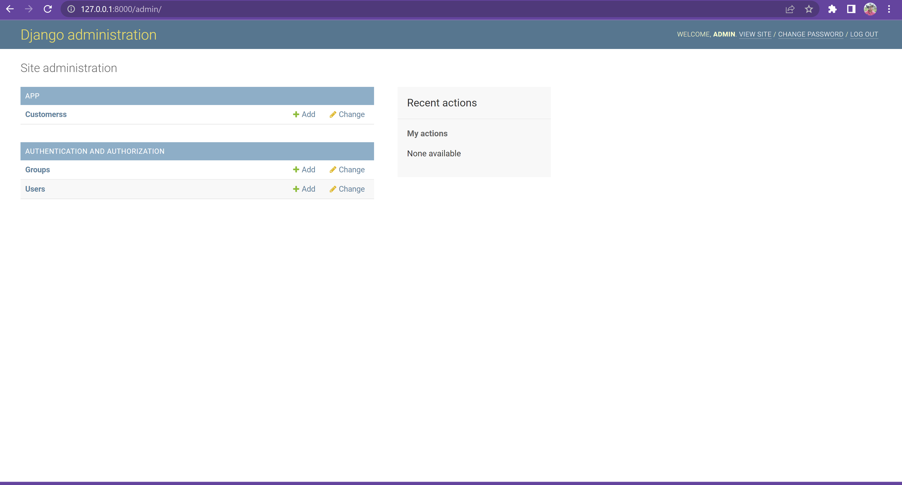

1. Create A BQ project on google developer console (Free account).
   1. Remarks – Free account don’t support data streaming hence took paid one
2. Create a Datastore on BQ.
   1. Done

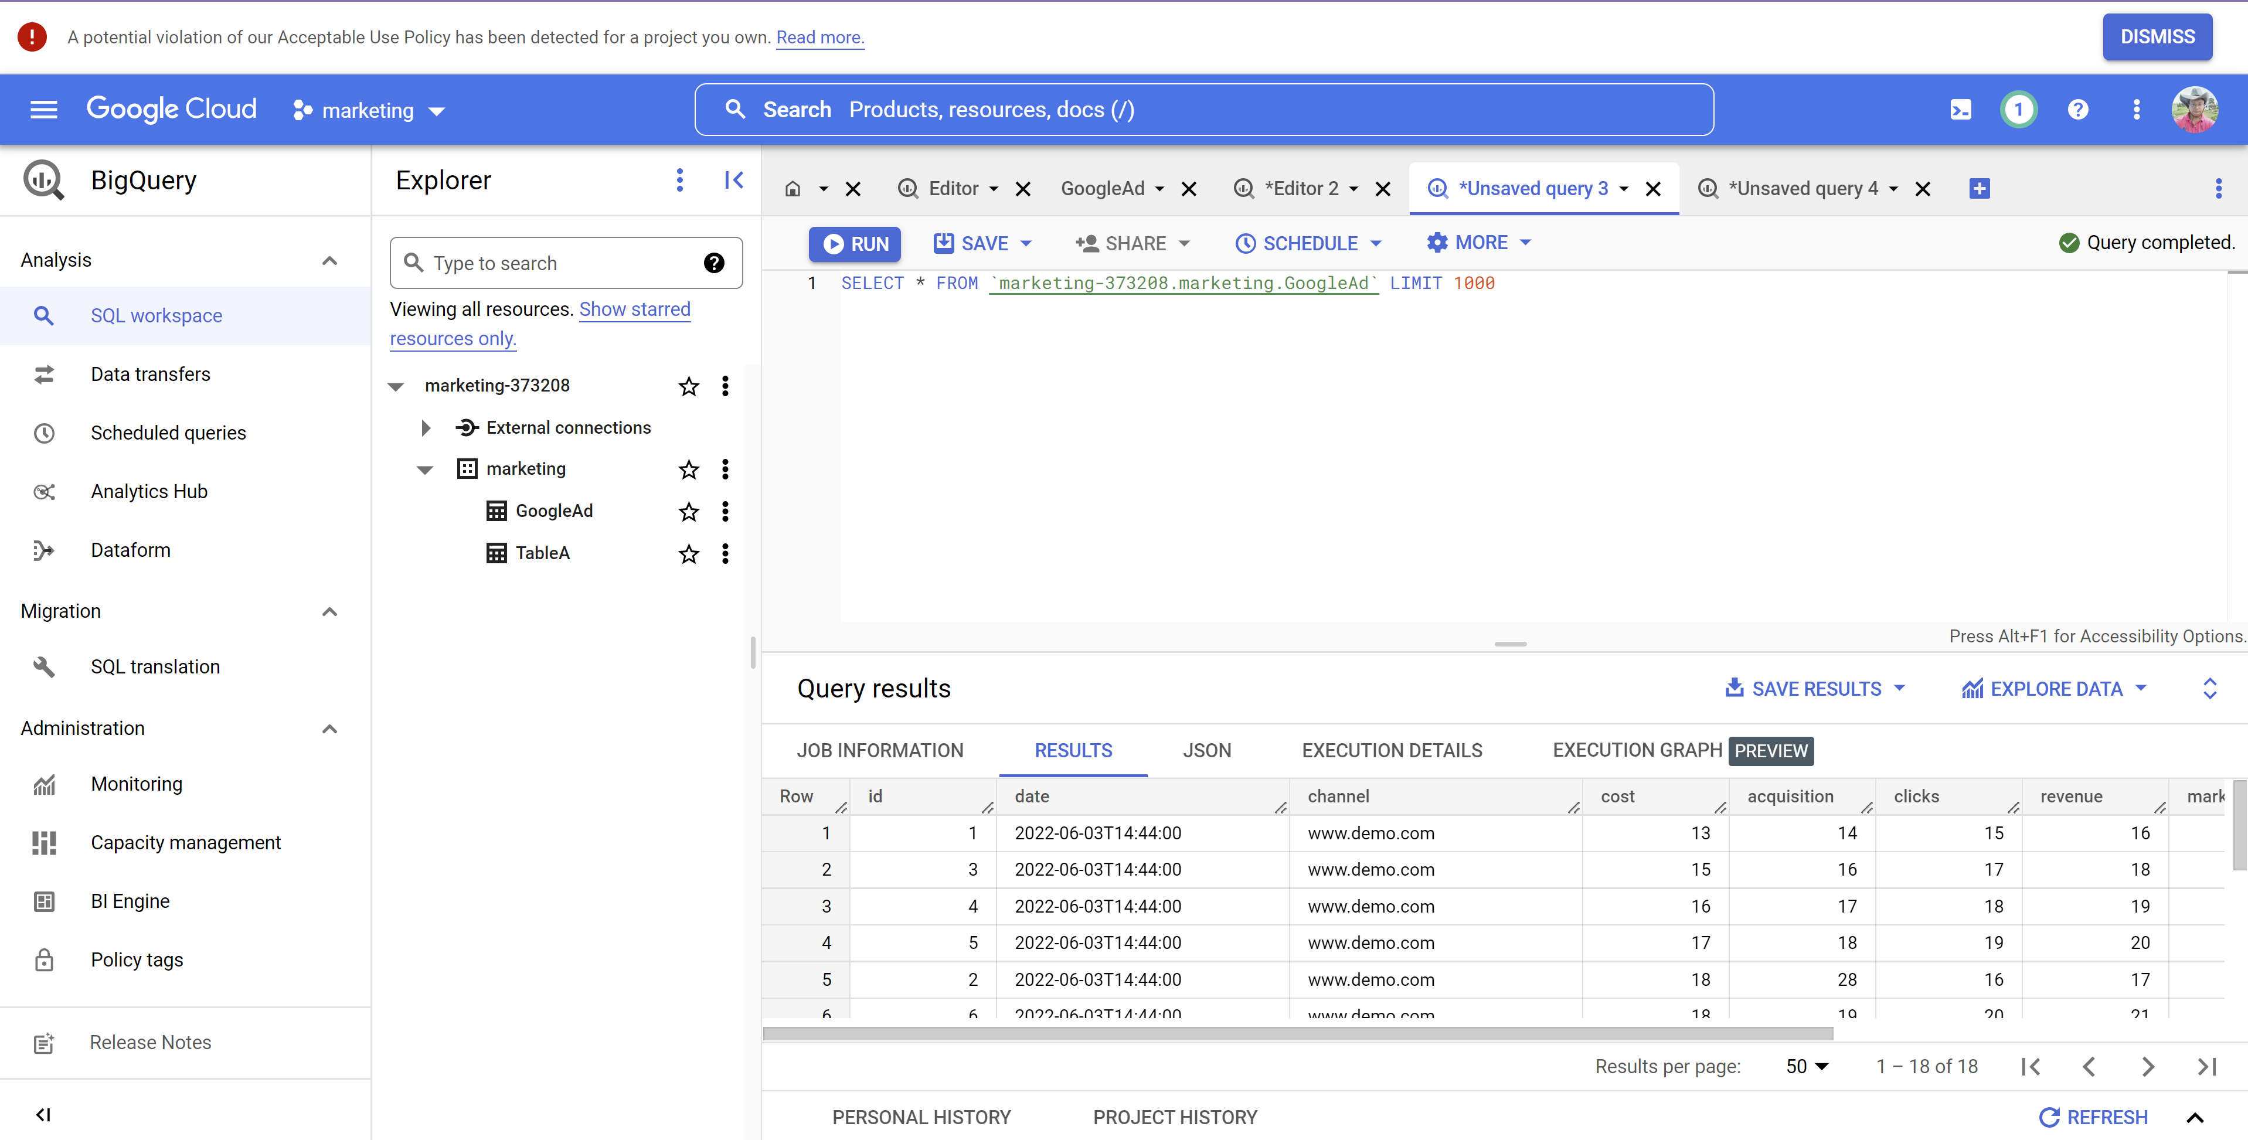

**Step 2:**

1. Create a Table called “TableA” in the datastore created above with some random data.
   1. Done

**Hint**: For help, Google provides some dummy dataset to play around.

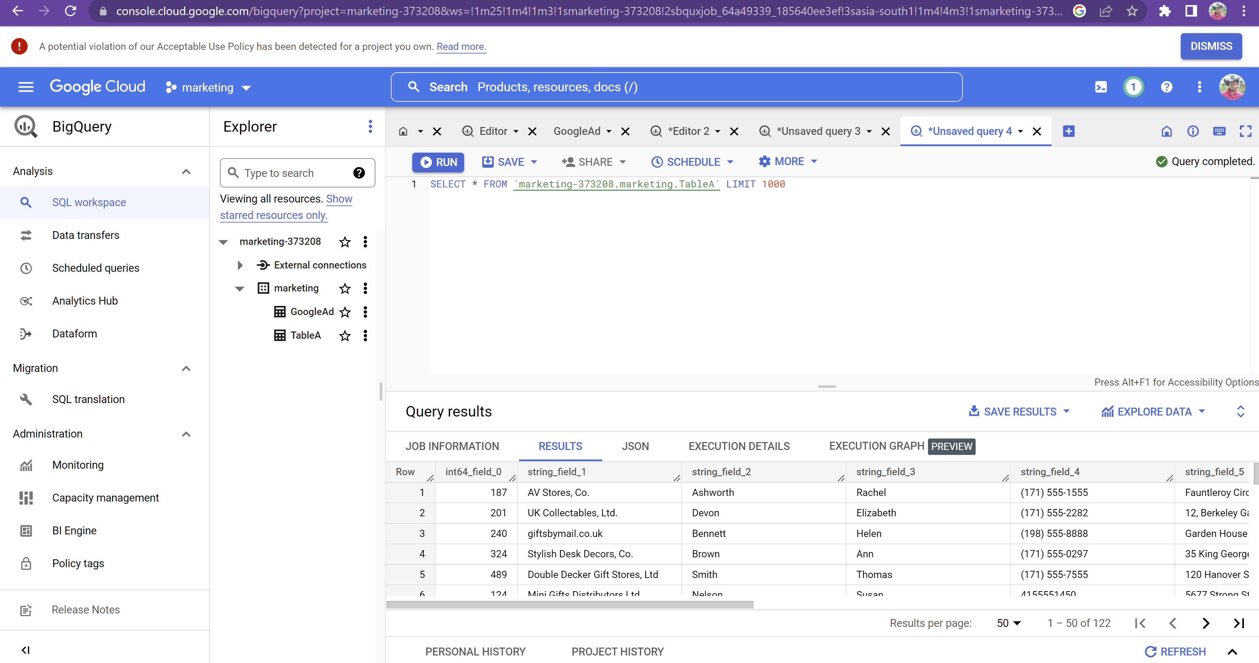

1. Import the data of table “TableA” to a local Database [your laptop] (Postgres/Mysql) and display the data in Django Admin.
   1. Done

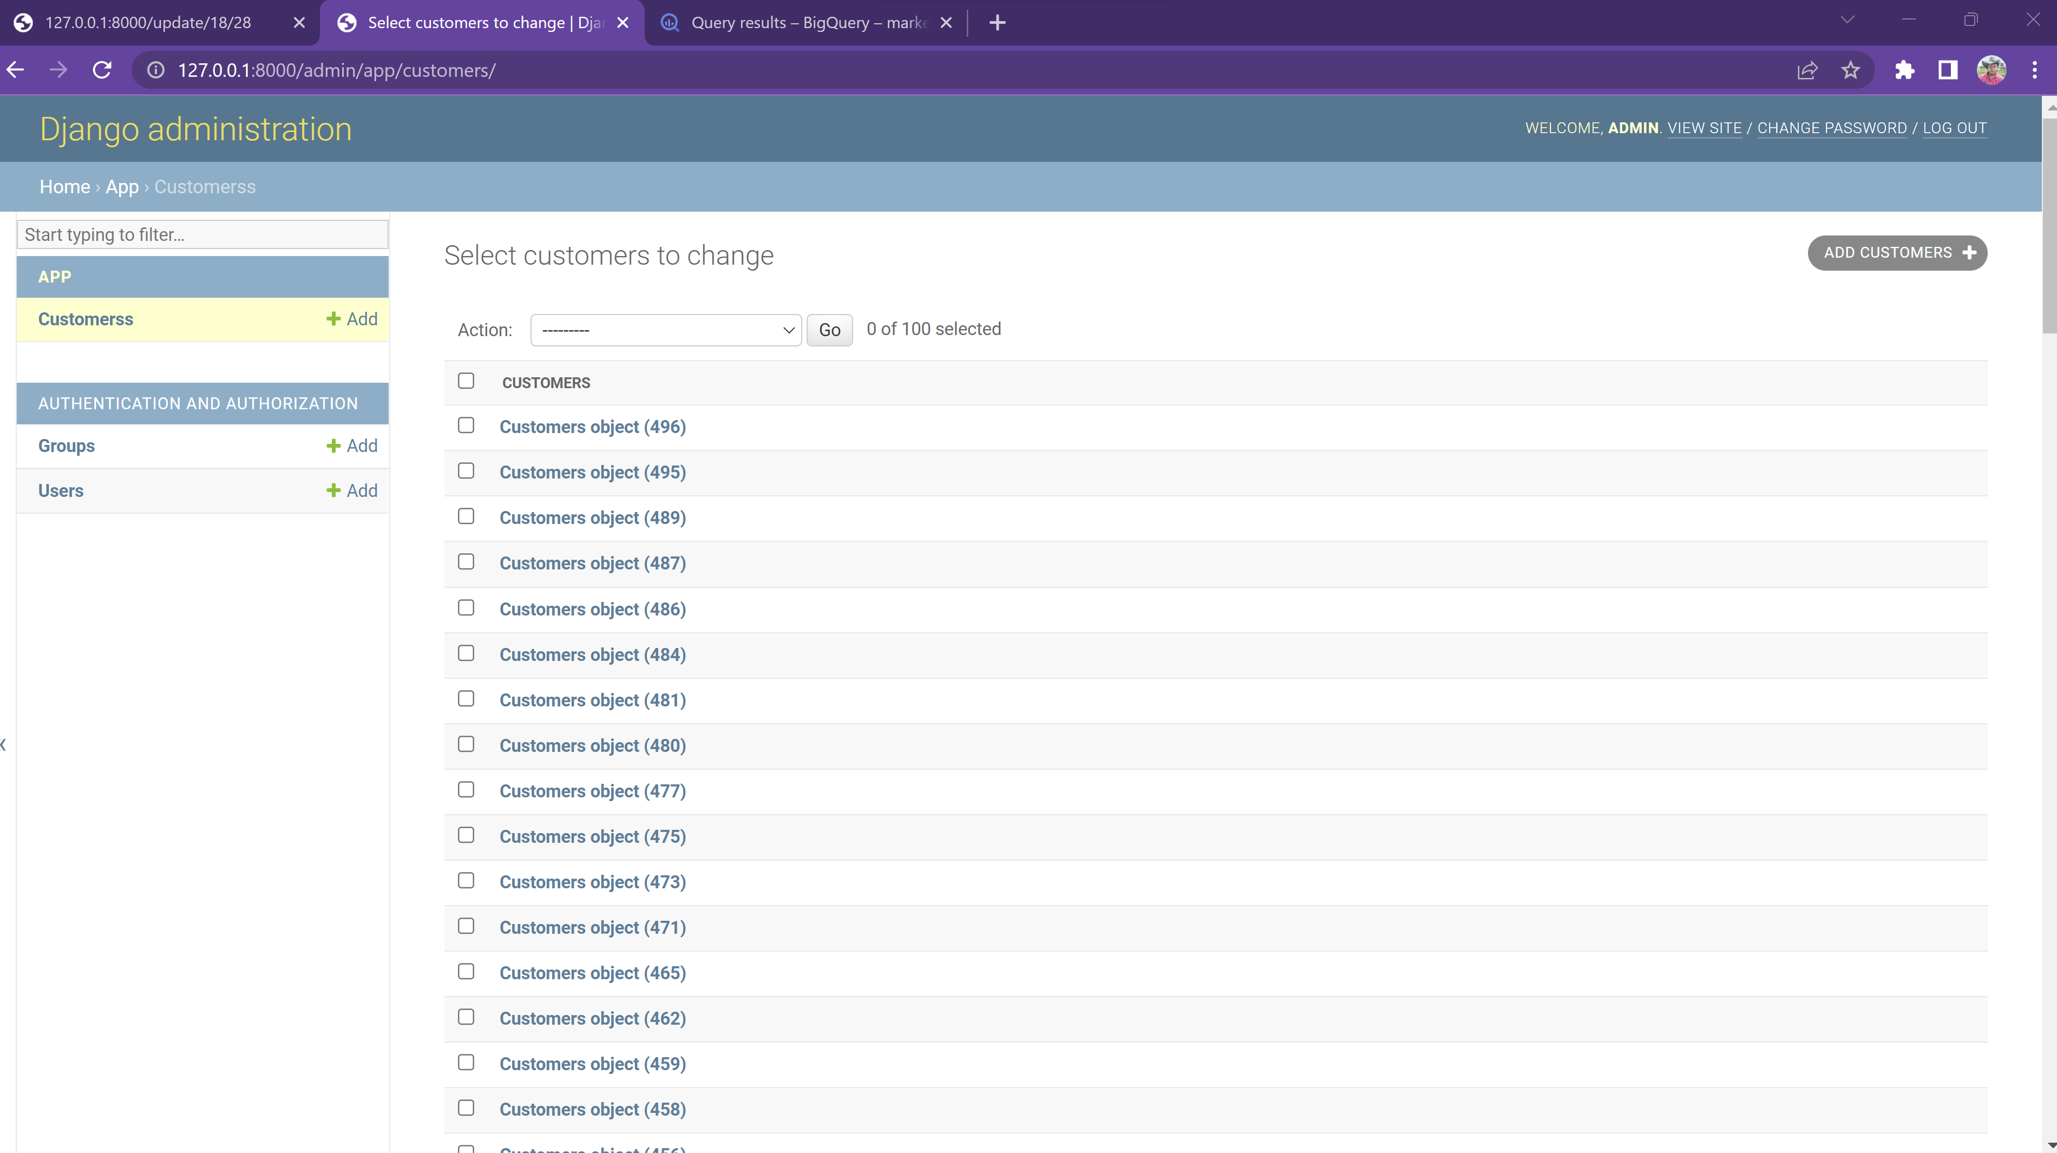

**Step 3:**

1. Create a table named **GoogleAds** in the datastore created above.
   1. Done
2. Upload some dummy ads data to the table - **GoogleAds** with python script using google’s BQ python library. (**Hint**: You can be creative here. Be free to upload ads dataset you could find online).
   1. Done

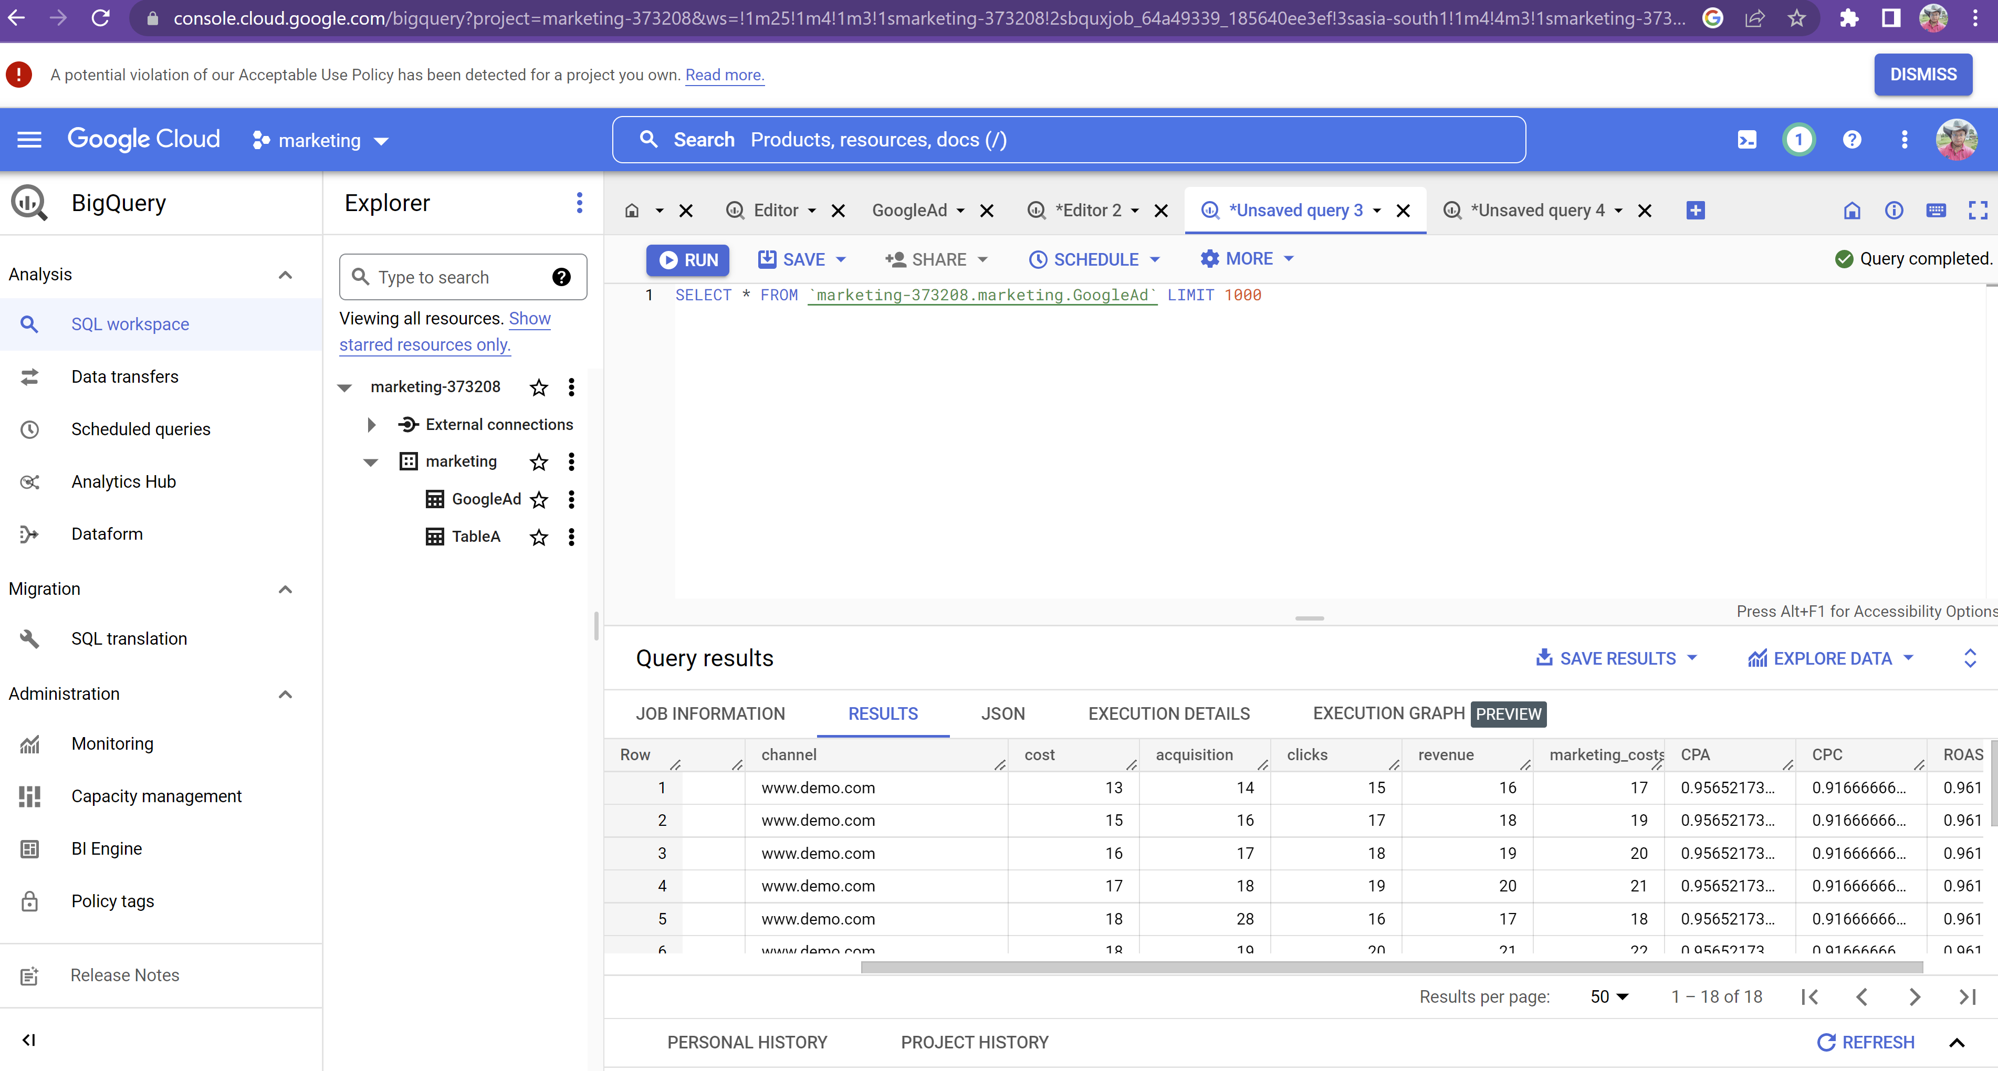

1. Calculate Ad metrics below and update the BQ table **GoogleAds (You might need to create new columns for the metrics on BQ table)**:
   1. CPA
   2. CPC
   3. ROAS
      * *Done - Functions in Views .py*

**Step 4:**

1. Write a python script to perform the action (a - c) below to Google ads accounts in the **GoogleAds** dataset (which you upload to BQ in above step) using python SDK (<https://developers.google.com/google-ads/api/docs/client-libs>).
   1. Pause Ad
      * *Done* addSetUnset *Function in Views .py*
   2. Unpause Ad
      * *Done* addSetUnset *Function in Views .py*
   3. Update Ad attributes (any two)
      * *Done - Update Function in Views .py update(self,cost,acquisition):*
      * *Below 18 as cost and 28 as acquisition*

*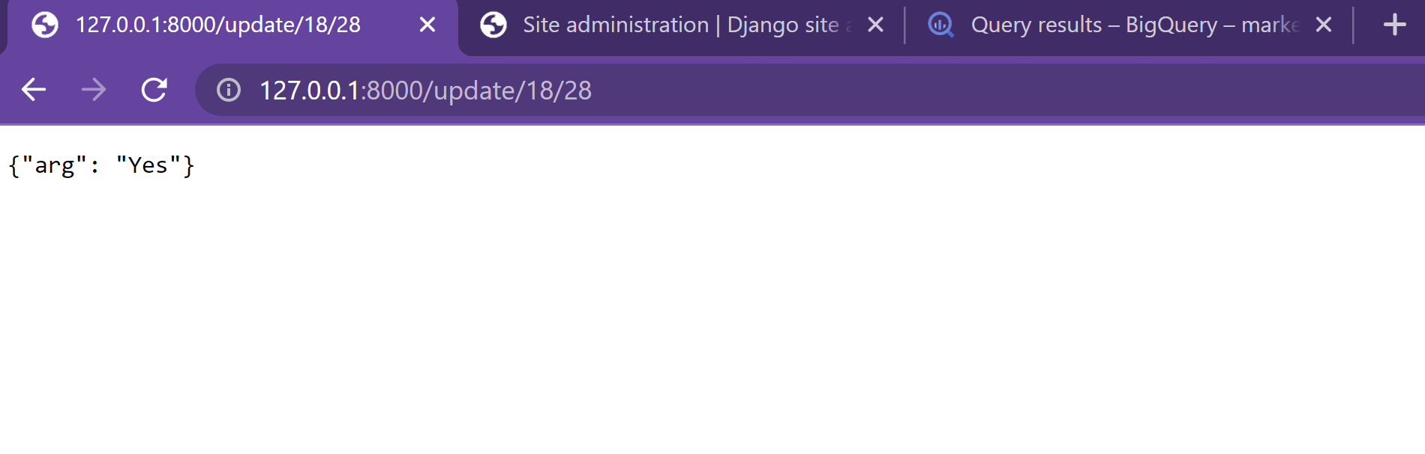*

\*\* Write unit test case of any of 1 module created above. (Must use mocking while testing.)

1. Done for update function python manage.py test

Please share the github link of the repo.